Rotating Element Installation
Take care not to damage any components and avoid contamination (dirt, debris, moisture, etc.) of the unit. Peerless does not recommend reusing gaskets, O-rings, packing rings, or ball bearings.
NOTE: Shaft sleeve set screws do not ship tight or with Loctite applied. Ensure step #7 is completed before startup.
1. Remove upper casing, bearing caps, and casing gasket to prepare for installation of new rotating assembly.
2. Ensure outboard deflector (40B) and coupling key (46) are installed.
3. Affix the new casing gasket (73A) to the lower casing (1A) with lubricant. It is very important that the specified material and thickness are used for casing gasket. Machined surfaces of both casings must be perfectly clean and free from burrs or nicks.
4. For the 12AEF21, follow step a before step b, for all other models follow step b only: a. If the bearings bracket has been removed, install it before setting the rotating element into the lower casing. b. Use slings around the shaft near the bearings to set the rotating element into the lower casing. Verify the rotation of the assembly is correct.
5. Position the casing rings (7) and both bearing housings so that all dowel pins engage in slots in the lower-case split surface.
6. Assemble both bearing caps per match marks and tighten the cap screws.
7. Adjust the shaft sleeves (14 and 14A) to center the impeller in the lower casing, and tighten both shaft sleeves with a spanner wrench, then add Loctite 243 (provided with replacement assembly) to the shaft sleeve set screws. Tighten the set screws to a minimum torque of 12 ft-lbs. Apply a 360° bead of thread locker to the first few threads, leaving the first thread-free.
8. Cover the top side of the casing gasket with a lubricant.
9. Install the gland bolts (17B). Carefully locate the upper casing on the lower casing, making certain the dowel pins engage.
10. Install cap screws and tighten working from the center of the casing to each end, to the torque values in IOM section 8.2.4 Tightening torques If any cap screws require replacement, use only parts with equal or greater tensile strength. See 8.2.4 Tightening torques.
11. Rotate shaft by hand to check that it turns freely.
12. Push the stuffing box bushings (63) to the rear of the stuffing boxes.
13. Clean the stuffing box to prepare for packing ring installation.
14. Install packing rings and stagger the joints 90° apart. The rings should butt tightly, but not overlap at the joints. When a lantern ring is required, make sure that sufficient packing is inserted below the lantern ring so that the bypass line intersects the packing container bore adjacent to the lantern ring and is not blocked by the packing.
15. Tamp down the individual packing rings, but not too tightly, as this may result in burning the packing and scoring the shaft or shaft sleeve. Insert two packing rings, lantern ring (29), if required, and three packing rings.
16. Replace the water seal piping. The pipe supplying sealing liquid should be fitted tightly so that no air enters. If the pumped liquid is dirty or gritty, clean sealing liquid should be piped to the stuffing box to prevent damage to the packing and shaft sleeves. Clear sealing liquid is also required if the stuffing box materials are not completely compatible with the pumped liquid. The sealing liquid should be at a pressure sufficient to ensure a flow of clean liquid into the pump, but not so high as to require excessive tightening of the packing.
17. Insert the packing glands (17) and set the gland bolt nuts finger tight. The stuffing box gland must not be too tight during startup to let sufficient liquid lubricate the shaft and the packing.
18. Rotate shaft by hand to check that it turns freely.
19. Replace all drain plugs if removed during disassembly.
20. Re-lubricate the bearings. See section 4.1 Lubricating the pump.
21. Make sure that the pump shaft spins freely.

9. Parts list and sectional drawings
9.1 AEF
TM072349
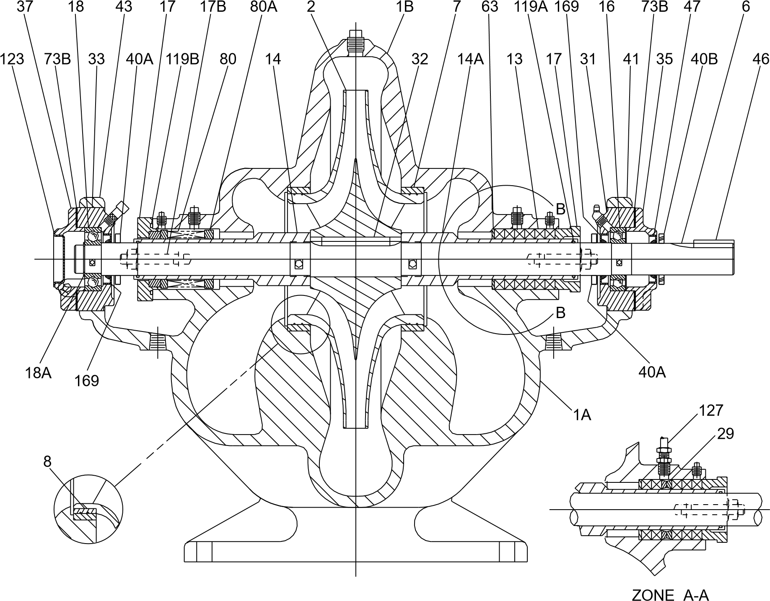
Fig. AEF, packed type
Item No. | Description | Item No. | Description
1A, 1B | Upper and lower casing | 33 | Outboard bearing housing
2 | Impeller | 35 | Inboard bearing housing cover
6 | Shaft | 37 | Outboard bearing housing cover
7 | Casing wear ring | 40A | Inboard deflector
8 | Impeller wear ring (optional) | 40B | Outboard deflector
13 | Packing ring | 41 | Cap, bearing, inboard
14, 14A | Shaft sleeve RH LH | 43 | Cap, bearing, outboard
14B | Shaft sleeve O-ring | 46 | Coupling key
16 | Inboard ball bearing | 47 | Inboard bearing cover seal
17 | Packing gland | 63 | Stuffing box bushing
17B | Gland bolt | 73A | Volute gasket (not shown)
18 | Outboard ball bearing | 73B | Bearing cover gasket
18A | Bearing lock washer | 123 | Bearing end cover
29 | Lantern ring (optional) | 127 | Water seal piping
31 | Inboard bearing housing | 169 | Bearing housing seal
32 | Impeller key

4. Preparing the pump for startup

4.1 Lubricating the pump
Before attempting to start the pump, check the following items:
- lubrication fitting at packing, if applicable
- lubrication for pump bearing
- lubrication of the driver
- oil-cooling connections for the driver, if applicable
- coupling, refer to the manufacturer's instructions.
Good practice includes the following:
- Keep lubricant clean and use a dust-tight cover on the storage container.
- Use the oldest lubricant first.
- Clean the pump lubricant fittings before re-lubricating with grease.
- Use clean dispensing equipment.
- Remove 0.25 in (6.4 mm) of drain pipe plug on the bottom outside of the bearing housing cover. Inject clean, new grease forcing out the old grease through the drain opening.
- Start and run the pump for a short time to eject any excess grease. Reinstall 0.25 in (6.4 mm) of pipe plug. Wipe off any ejected grease.
- Use the proper amount of lubricant. Too much lubricant results in churning, unnecessary power consumption, rapid heating to a high temperature and inadequate lubrication.
Normal bearing temperatures vary with the seasons and environment and may range from 0 to 250 °F (-18 to 121 °C). A continuous rise from the established, normal operating temperature indicates trouble and probable failure of the bearing. Shut down the pump immediately.

8.2.4 Tightening torques
Proper tightening of fasteners is very important. The torque values depend on the size and grade of the fasteners used. The values in the table below apply to non-lubricated parts.
Fastener size | Torque  [lb-ft (Nm)] | Torque  [lb-ft (Nm)]
 | Medium carbon steel  SAE J429 Grade 5  105-120,000 psi  Tensile | Medium carbon alloy steel  SAE J429 Grade 8  150,000 psi  Tensile
1/4-20 | 8 (10.8) | 9 (12.2)
3/8-16 | 25 (33.9) | 34 (46.1)
1/2-13 | 62 (84) | 83 (112.5)
5/8-11 | 125 (169.5) | 166 (225.1)
3/4-10 | 225 (305) | 295 (400)
7/8-9 | 325 (441) | 477 (646.7)
1-8 | 465 (630.5) | 715 (969.4)
When assembling a pump, cross-tighten the screws in order to avoid misalignment, binding and leakage.
TM073806
Fig. Tightening pattern for 4-, 8-, or 12-bolt flange
Shaft sleeve set screws: 12 lb-ft (14.7 Nm)
The shown torque value is for clean lubricated threads and gasket joints.

